SURVIVAL, EXPANSION, AND ADVANCEMENT OF WHITE RACE



*SIMULACRUM CANDIDUS*

Major Project Design Work

Peter Haile - Nabeel Lalji - David Tran - Cole Rees

A00776844 - A00711791 - A00801942 - A00741578

COMP 8506 Set 7D

British Columbia Institute of Technology

Aman Abdulla

Thursday, October 30 2014

Table of Contents

# 

# Introduction

The Internet that we know today is both a blessing and a curse. The Internet provides us with knowledge and entertainment that can further enrich our lives. However, there is a dark side to the Internet; there are malicious users out there that strive to take advantage of unsuspecting users. These people -- hackers -- are talented and dangerous in the field of cyber warfare and are unrelenting in their path to gather information on whatever they want. This “information” comes in the form of passwords, administrator accounts, credit card credentials, etc.

No matter the extent of mitigation that we go through, it is still a game of tug-of-war between network administrators -- the good guys -- and the hackers. Each layer of security invokes a challenge to hackers to penetrate into the network core. While we still continue to be diligent in our efforts to mitigate and prevent hackers from getting in, many business organizations experience these attacks.

So that begs the question: how do we stop them? As network administrators, we have determined and seen first hand that the weakest link to the security chain is through the users. Users are often too neglectful in security and too trusting of things that are too good to be true. The first method of prevention of attacks, therefore, is to educate the users of the existence of attacks. However, in order to do so, we -- the network administrators -- need to educate ourselves.

In turn, the purpose of this project is to initialize a legitimate, but decoy network in order to bait the hackers into hacking our network, effectively capturing all of the attacks a hacker may attempt. In doing so, the hacker would leave footprints in the form of log files for us to slowly decipher and make sense of the evidence of their attacks. Once we understand the processes that they go through, the better we are at understanding how to prevent these attacks and how to effectively relay the message to other non-technologically literate members.

Once we deem that our network has been compromised enough, we will take the network offline to conduct a post-mortem analysis on the network and on each node of the network. Our project deliverables shall include our findings, analyses and any suggestions for future mitigation of such attacks.

At this time, we shall be including evidence of reconnaissance activities on our network conducted by ourselves to illustrate and provide insight to the audience of our plan. Actual analyses and findings of hacking will be in the final report documentation.

# 

# 

# Network Design & Setup

Our personal network design is as follows:

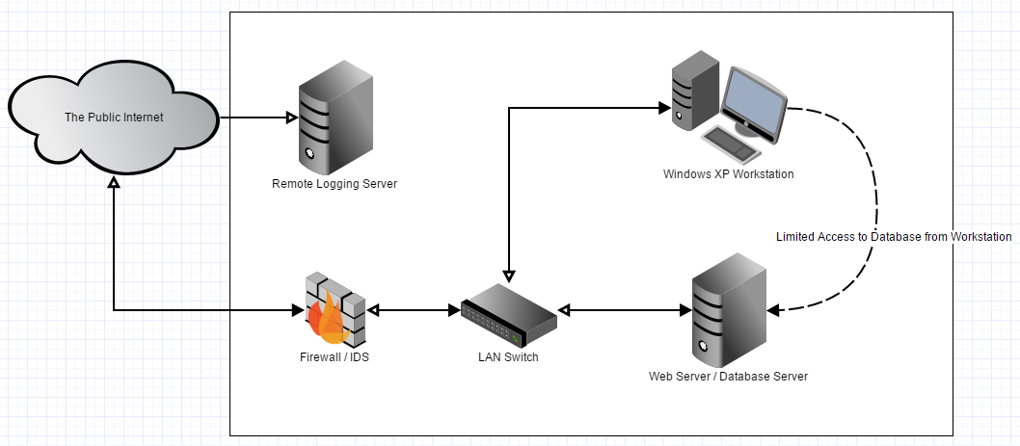

The Windows XP desktop and the Fedora 19 Apache Web Server are apart of the same subnet. They have the IP addresses 192.168.25.2 and 192.168.25.3 respectively. This subnet is possible due to the firewall server having two Network Interface Cards, NICs.

The firewall’s NICs are labeled as “em1" and "enp0s29f7u2". The em1 NIC is connected to the internet and can be referred to as the public NIC, since it is where outside traffic will be coming in through. The NIC labeled enp0s29f7u2, is the local, or LAN, NIC. Only traffic for the subnet, in which the two clients reside, shall be traversing this NIC; it is the default gateway for both the clients.

To enable traffic to be forwarded from em1 to enp0s29f7u2 we must first configure the firewall. This was achieved using the tool iptables and altering the routing tables, explained below.

The following points highlight key characteristics of each component in the diagram:

## Stand-Alone External Firewall

|  |  |
| --- | --- |
| * Operating System: Fedora 19 Linux 64-bit * Firewall: IPTables * Hardware: Dual Network Interface Cards * Software: N/A | * SSH to Web Server: 174.7.33.60:3450 * HTTP to Website: 174.7.33.60:8080 |

### 

### 

### Firewall Implementation

In this particular network, the firewall is setup to block incoming traffic to the firewall and to only allow specific traffic to and from the internal servers. The firewall itself does not allow external access however the two internal clients, one being Linux based and one being Windows based, allow for Secure Shell, SSH, and Remote Desktop Protocol, RDP, connections respectively.

SSH is a protocol in which two computers can communicate via a secure channel using remote command-line login. When a connection has been made SSH allows for remote command execution and secure data communication. The SSH service listens on port 22, however the firewall in this network is setup to listen for SSH traffic on port 3450 and forward to client 1’s port 22.

RDP is a protocol that allows for remote connection to a windows based computer. This protocol grants you access to a computer via a graphical interface in which it displays the actual visual output that the computer is generating (ie. Screen to screen). RDP runs on the TCP port 3389, the port that the firewall is listening on and forwarding to client 2.

Additionally, the firewall allows access to an internal web server hosted on client 1. The firewall accepts only NEW or ESTABLISHED connections to the web server. It listens on port 8080 and redirects the http requests to port 80 on client 1.

|  |  |  |  |  |
| --- | --- | --- | --- | --- |
| **Name** | **Firewall Port** | **Forwarded to** | **Port** | **Protocol** |
| **SSH Connection** | 3450 | Client 1 | 22 | TCP/UDP |
| **RDP Connection** | 3389 | Client 2 | 3389 | TCP/UDP |
| **HTTP Server** | 80 | Client 1 | 80 | TCP |

Above is the forwarding table for the firewall. The Firewall Port column signifies the only open ports on the firewall. During reconnaissance on this network, those are the only ports that should show up.

To set up the firewall to allow such connections we used the tool iptables. Iptables allows you to block, accept or forward traffic being sent to the network. In this case most of our traffic is being forwarded to the two clients in the subnet. The script used to add these rules can be found scripts folder.

As mentioned, the firewall must first be configured to allow for traffic to be forwarded. This is achieved by setting the local NIC to the desired IP of 192.16.25.1. This IP is the default gateway for the two clients. After, we must add “1” to the file ip_forward file to allow the machine to actually forward traffic. To finish the configuration, we add two routing rules: one to specify that the public NIC, IP 174.7.54.127, is the default gateway for the subnet 192.168.0.0, where the local NIC sits, and one to specify that the local NIC, IP 192.168.25.1, is the default gateway for the subnet 192.168.25.0, where the clients reside. This configuration was achieved using the following script:

*ifconfig enp0s29f7u2 up 192.168.25.1*

*echo "1" >/proc/sys/net/ipv4/ip_forward*

*route add -net 192.168.0.0 netmask 255.255.255.0 gw 174.7.54.127*

*route add -net 192.168.25.0/24 gw 192.168.25.1*

## Switch

Our switch is a residential router with wireless disabled. This functionality is achieved through placing all the network working cables in the LAN ports on the router. There should be no cables going into the WAN port on the router (ie. do not give the router access to the outside).

## Apache Web Server

|  |  |
| --- | --- |
| * Operating System: Fedora 19 Linux 64-bit * Firewall: No firewall * Hardware: N/A * Software: SCP | * MySQL Database & phpMyAdmin GUI * Apache Webserver * Website - CodeIgniter Framework * Website - Using PHP |

### Website (Exploitable) Components

The theme of the website is “Religious Terrorism”. Our team does not condone or practice any of the comments made on the website. It is simply a means to provoke attackers in the future. The website uses a PHP Backend which will allow us to have the following components:

#### MySQL Database Integration

The purpose of having database integration with the website is to add another point of failure, another path for exploitation and to better replicate modern day websites as a proof of concept. The database will be storing some of the contact information gathered from the HTML forms as well as any other information that we find is enticing to an attacker.

#### HTML Form Processing

The component is the Join page, where the user can enter their credentials that will be stored in the database. The ultimate purpose of these forms is to provoke the attackers, if any, for SQL Injection. The forms and their backend have limited error checking, escaping or encoding. The only “real” limitation for attackers to use SQL injection is the size constraints of the database entries themselves. For example, while we have no strict size limits on the form itself, the Contact Phone Number is restricted to 10 - 13 characters, if they were to use dashes.

## 

## 

## Local Workstation

|  |  |
| --- | --- |
| * Operating System: Windows XP Professional - Black Edition 32-bit SP3 * Firewall: None * Hardware: N/A * Software: N/A | * Web Access to phpMyAdmin: 192.168.25.2/phpmyadmin * Website: 192.168.25.2 * Remote Desktop Protocol enabled |

The local workstation has local access to the web server and phpMyAdmin; nothing else.

## Remote Log Storage Machine

|  |  |
| --- | --- |
| * Operating System: Fedora 19 Linux 32-bit VM * Firewall: None * Hardware: Storage Size - ~1GB * Software: VMware Workstation * Parent Operating System: Windows 8.1 64-bit | * SSH to Web Server: 174.7.33.60:3450 * HTTP to Website: 174.7.33.60:8080 * Remote Desktop (from PC to Workstation 174.7.33.60 * Tools: rsyslog |

The storage machine also has a public and private key exchange with the Web Server. This allows scheduled file transfers using scp and cron without the need for the administrator to enter their password.

## Reconnaissance Machine(s)

|  |  |
| --- | --- |
| * Operating System: Linux Kali Live USB + VM * Firewall: (where applicable) | * Hardware: N/A |

This is a high-level description of the machines that, as each individual on the team, will carry out the active and passive reconnaissance.

# Tools & Equipment Used

## Hardware

|  |  |  |
| --- | --- | --- |
| * Stand-Alone Firewall | * Switch / Router | * Web Server |
| * Internal Workstation | * External Log Storage | * Recon. Machine(s) |

## Software

|  |  |  |
| --- | --- | --- |
| * Fedora Linux 19 64-bit | * Windows XP SP3 | * Kali Linux Live USB |
| * nmap / Zenmap | * Windows RDP | * rsyslog & journalctl |
| * Apache / httpd | * phpMyAdmin | * MySQL & Server |
| * CodeIgniter | * Snort IDS | * SnortSnarf |
| * Mimikatz |  |  |

# 

# Our Approach & Exploits

The following exploits were deliberately made in order to perform a post-mortem analysis after the network has been compromised by other hackers than ourselves. The difficulty of each exploit is determined by our team and is ranked based on the difficulty of detection. Below is a brief summary of how we will attempt to collect data based on the respective exploits:

## Easy Difficulty Exploits

### SQL Injection on HTML Forms

In our web application, we have coded the HTML form with limited requirements for error checking. This is intentional to allow the hackers to attempt SQL injection within our form. By implementing any features of preventing SQL injection, we may not be able to capture the data for later analysis. Below is screenshot of the CodeIgniter PHP code:

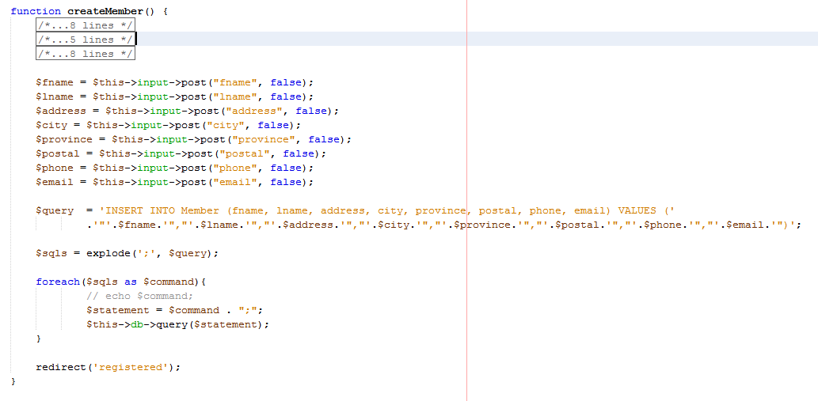

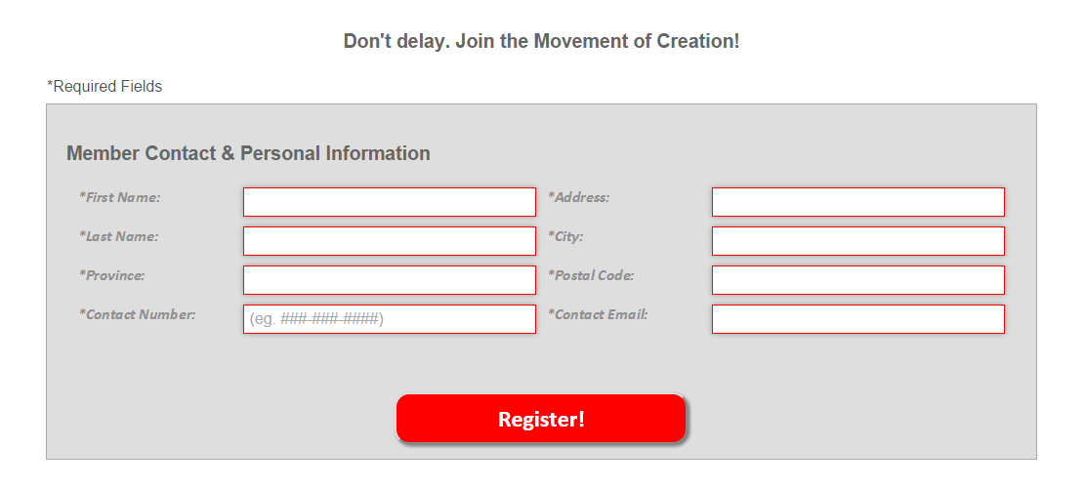

Particularly, note the following snippet of code:

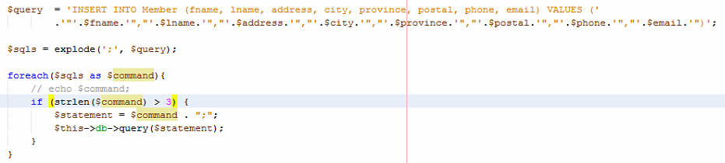

The SQL statement here is, rather than using a model in our MVC architecture, we have opted to use a raw SQL statement. The explode function with delimiter “;” is used to parse through multiple SQL statements in this query string. Recall that we purposefully wanted SQL injection as part of our functionality; this explode function and the following foreach loop, enables this. In the foreach loop, the each query string inside the $sqls array is checked for lengths greater than 3 and when it is, to execute those queries. This is done as an error checking mechanism to make the back-end discard trailing syntax errors.

### Password Brute Force for SSH

Our web server we will have an SSH server running. This is pretty typical for a lot of web servers. Poor passwords is one of the easiest ways to access user data, on our server we will use a medium strength password without any IPS services, so attackers will have unlimited attempts to crack the password.

## Medium Difficulty Exploits

### Mimikatz Password Dump

Our Windows XP machine will contain Mimikatz files on the desktop. This is to allow attackers to grab password dumps of our machine once they are able to penetrate through the login screen from Windows’ Remote Desktop Protocol. We will also pre-configure the Administrator password to be the same root password on the Web Server machine. Therefore, it will be an easy detection to see that the attacker has retrieved the Web Server’s password either through brute force tactics or through our Mimikatz exploit.

### Denial of Service Attack

Since our webserver is running on older hardware that ability for it to handle a larger amount of traffic will be limited. In theory it should be fairly easy to perform a denial of service attack on our web server using a SYN flood attack with hping3. The most complicated aspect of this attack is gathering enough machines that will be able to send enough traffic to the web server to cause it to crash.

## 

## 

## Hard Difficulty Exploits

### Shell Shock

One of the harder exploits we wanted to include in our honeypot was the Shellshock, otherwise known as “bashdoor”, vulnerability. Shellshock is a relatively new attack, initially being document on September 24th 2014. For this reason our web server is running an unpatched version of Fedora 19.

Shellshock is an attack which utilizes a bug in the bourne again shell scripting language, bash. Bash is a command-line shell and has been around since 1989 and an analysis of bash historical source code shows that this particular vulnerability has seen around since its inception.

The shellshock attack works by basically injecting a line of code into what is usually considered to be a plain-text variable. When bash reads this line, “() { :; );”, it thinks that it is the end of a command and as such will execute anything following it as a command. Therefor, you can inject this line into an http header variable, such as “User-Agent”, and send the packet to a working cgi (bash) script on a web server. Bash will read the incoming packet and execute the code.

### Remote Desktop Exploit on Windows XP

To follow with Shell Shock, we will include any findings regarding Windows Remote Desktop Protocol exploits. These are not concrete nor explicit exploits on our system but rather, to document any attacks that occur on our Windows machine or harm caused by it.

# 

# 

# Testing & Documentation

For the purpose of simplicity, we will only provide proof of concepts that these exploits exist. We will not intend to overextend and destroy or compromise our own network, if necessary.

## SQL Injection on HTML Forms

Recall that we have very limited to no validation on our web application. The database has been designed in such a way to have some constraints on the sizes of the input values. However, we will see that these “limitations” can easily be overwritten using SQL injection.

In our database backend, we have created an empty table called “CreditCard”.

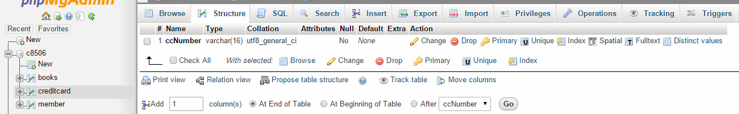

Here, we see the HTML form. We will enter some legitimate values for demonstration that the form works as intended.

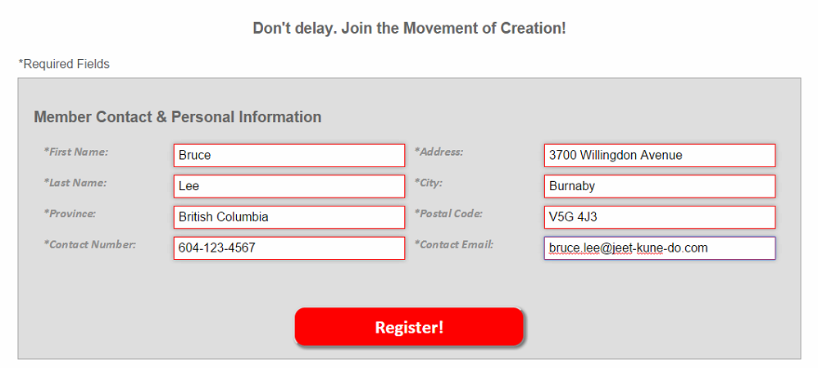

The web application will then ask the user to confirm their member information before entering the values into the database. If the user cancels, the link will redirect the users back to the “Join” page where they can re-enter their values, if necessary. To further add less security for our honeynet, we have made it so that none of the values are required, even though we asked for all fields to be populated.

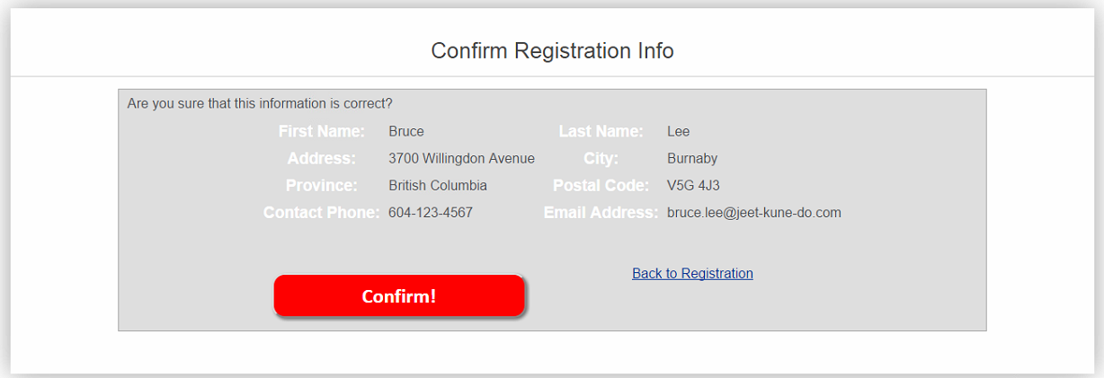

Once confirmed, the web application prompts the user that registration was successful. We can see that in the screenshot below, and a screenshot of the database with the new entry in the “Members” table:

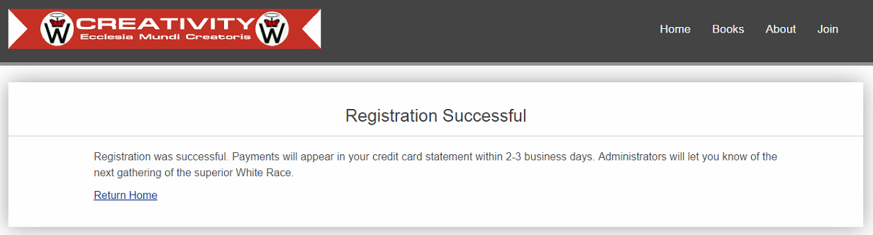

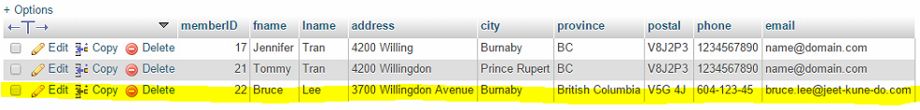

Now, let us go back and enter some malicious SQL injection code, such as dropping our blank “CreditCard” table. Our malicious code is

***‘person@some-domain.ext”); DROP TABLE c8506.creditcard;’***

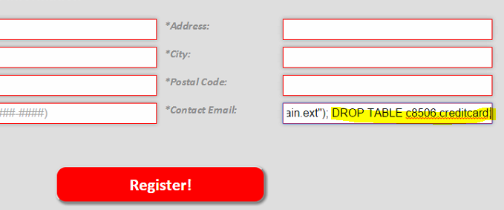

Note that the code will work easier if the code is placed in the “Email” input since it is at the end of the SQL statement. Once we go through the member confirmation page and the registration page, assuming that the queries are executed, we can confirm that the table “CreditCard” is gone.

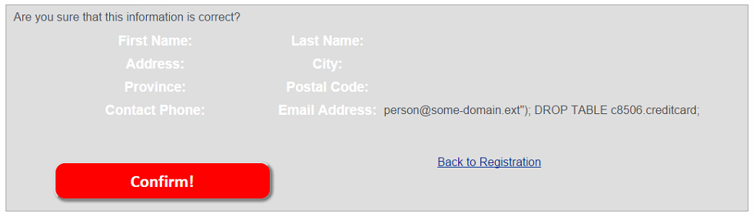



Our MySQL and phpMyAdmin backend:

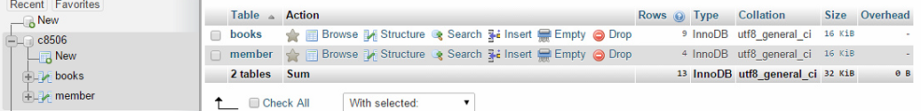

This therefore confirms that our web application is exploitable using SQL injection.

## 

## 

## Password Brute Force for SSH

First we will start with our attacking machine, by running xhydra we can get the graphical version of Hydra. In the first screenshot we can see that we have to set our target machine, the protocol we want to use to try to connect and various options at the bottom.

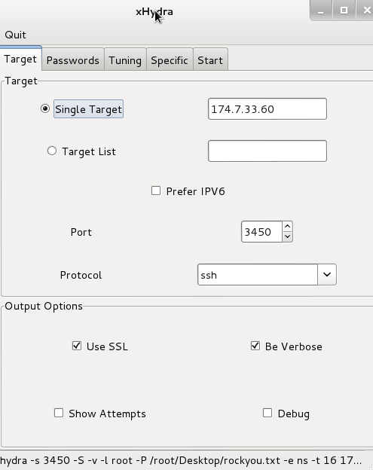

On the Passwords tab we set the password list we want to use. For the sake of this test we will only use.

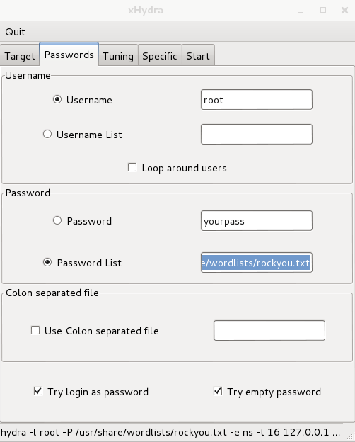

Here we can see the finished brute force, completed at 9:07AM and it found the ssh password to be uest1onQ?at@.

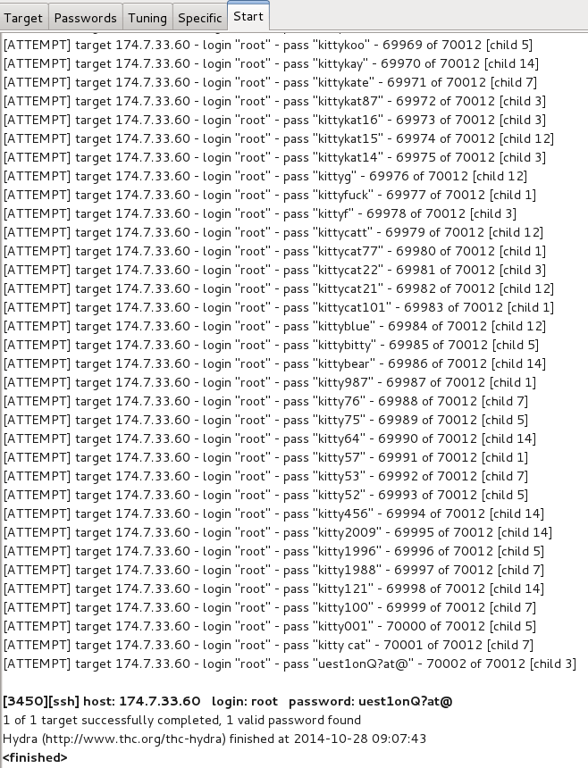

When we tried our next login to the compromised machine we can see the there were 220000 failed attempts at logging in, I believe this is due to hydra making multiple attempts on the same password to make sure it there was no network issues with the password attempt.

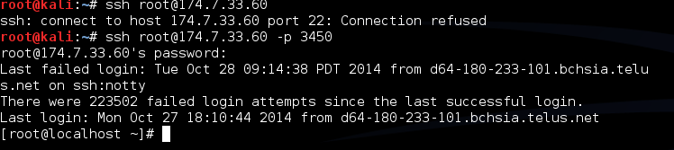

Below is a screenshot of the logs on the compromised web server, we can see this is the point in time where we started the brute force.

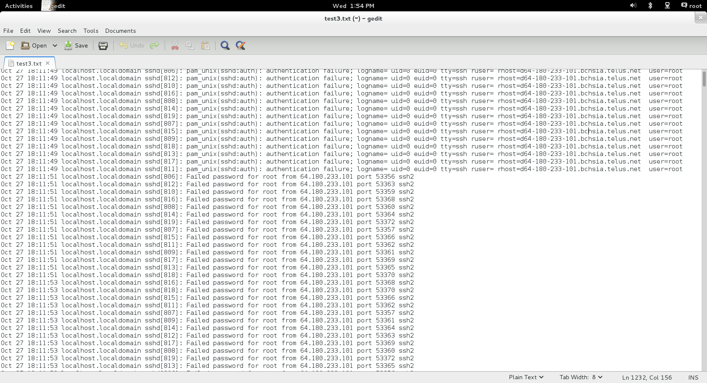

Next is an example of the password brute forcing in the middle of the night.

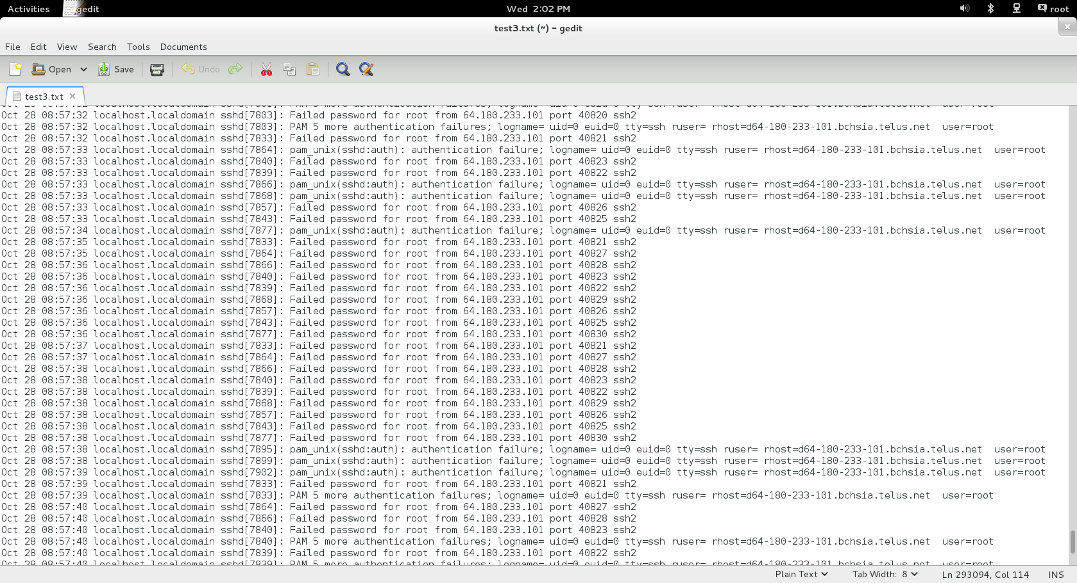

And finally we can see in the highlighted row we can see Hydra has finally found the right password combination at 9:07AM.

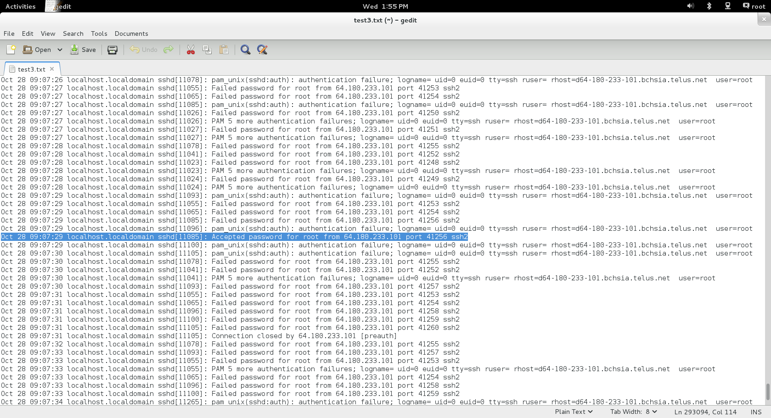

## Mimikatz Password Dump

On our Windows XP workstation, we have inserted Mimikatz onto the desktop, and have previously logged in with the Administrator account. This way, the password dumps will include the Administrator password, which will allow attacks to continue with their exploits on our system. We have purposefully made the Admin password to be the same as one of our other passwords on the network.

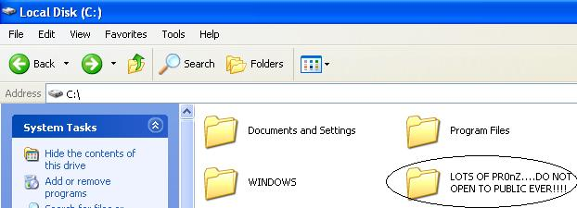

Let us open up a command console to execute Mimikatz. First we will check for **root** privileges, and then execute the password dump using the **sekurlsa module**:

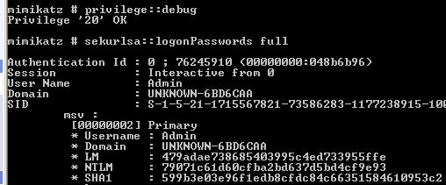

And behold, our passwords:

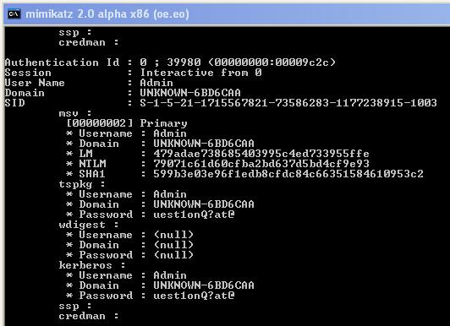

This therefore confirms that, once inside the machine, the attacker can use the purposefully and conveniently placed tools to further compromise our system.

## 

## 

## Denial of Service Attack

To conduct our denial of service attack, we gathered four Reconnaissance Machines and ran the following command in four different terminals per machine:

hping3 -i -u1 -p 80 174.7.33.60 -S --flood

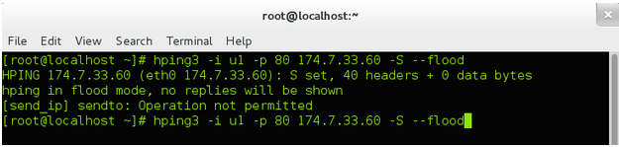

For a packet capture of the SYN flood attack, please refer to the attached Wireshark capture on disk: **DoS-capture.pcapng.gz**

In our Web Server, during the midst of our denial of service attack, we ran a status check on Apache and httpd. The following screenshot depicts our findings:

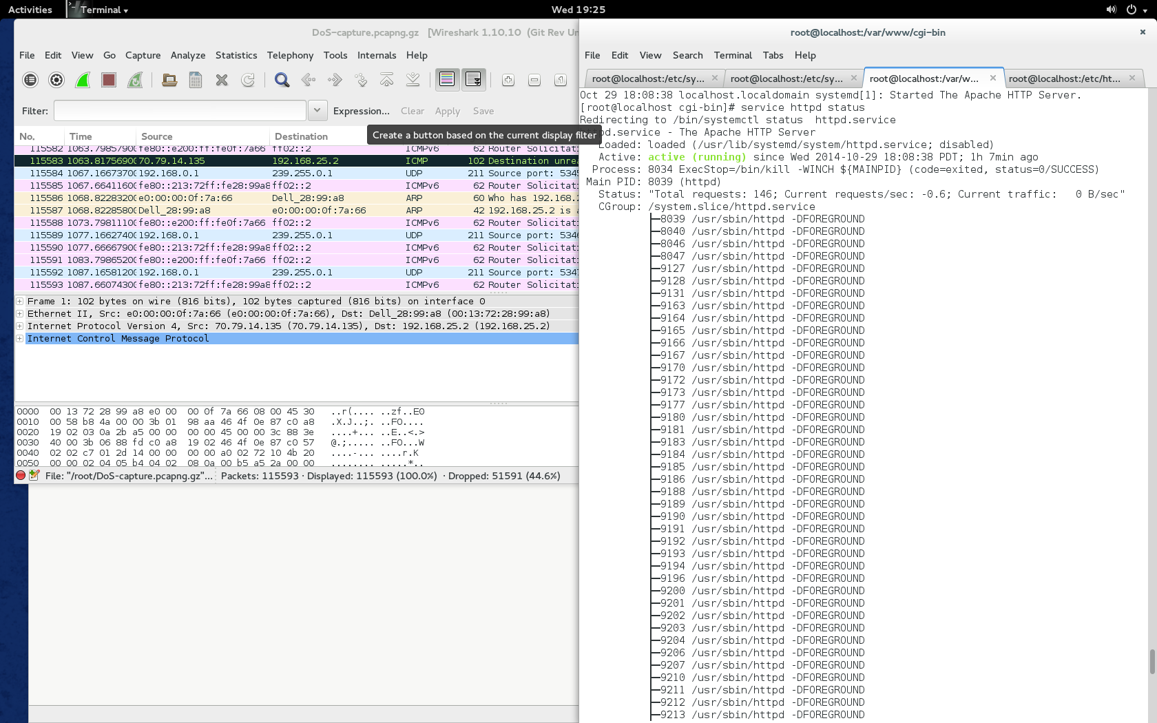

From our evidence above, we see a total of 146 simultaneous requests for the server. On a non-malicious server, attempting to visit the website resulted in a very slow response time. Although we were able to access the homepage of our website, we were surprised to see how our regular tool for firewall penetration testing could be an attacking mechanism. Therefore, we would then also assume that any action requiring the backend to do some form of processing and database insertion would require a tremendous amount of time and patience.

## Shellshock

This attack is only capable of being performed on a web server with cgi scripting available. For this reason, we have included a bash cgi script in our /var/www/cgi-bin directory where it is accessible from the web. To test our server for vulnerability against shellshock, we used a script provided by shellshocker.net. The following code for Shellshock testing was ran:

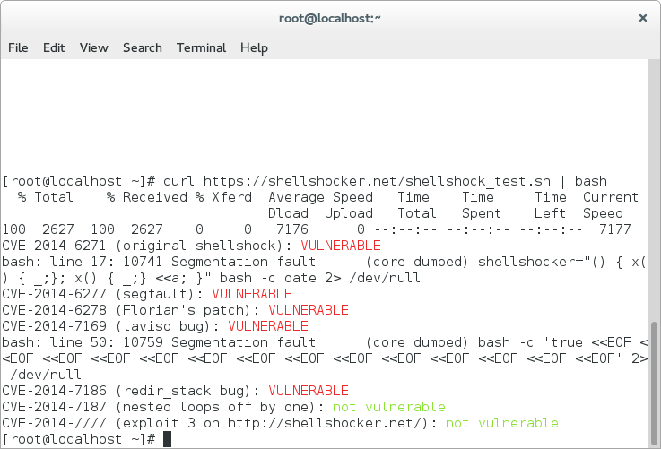

The script shows we are vulnerable to several different versions of documented shellshock attacks. The specific one we want is the “Original ShellShock” shown as **CVE-2014-6271**. The other versions of shellshock that we are vulnerable to include: **CVE-2014-6277**, **CVE-2014-6278**, **CVE-2014-7169**, and **CVE-2014-7189**.

During this test we show that snort alerts us to the fact that there is cgi activity. This is how we will track attackers attempting to use the shellshock attack on us. As shown below, snort alerts us to priority 2 warnings of cgi scripts being run on the server to the more severe priority 3 attacks, including: direct /cgi-bin/ access and perl execution (also one of the scripting languages susceptible to shellshock).

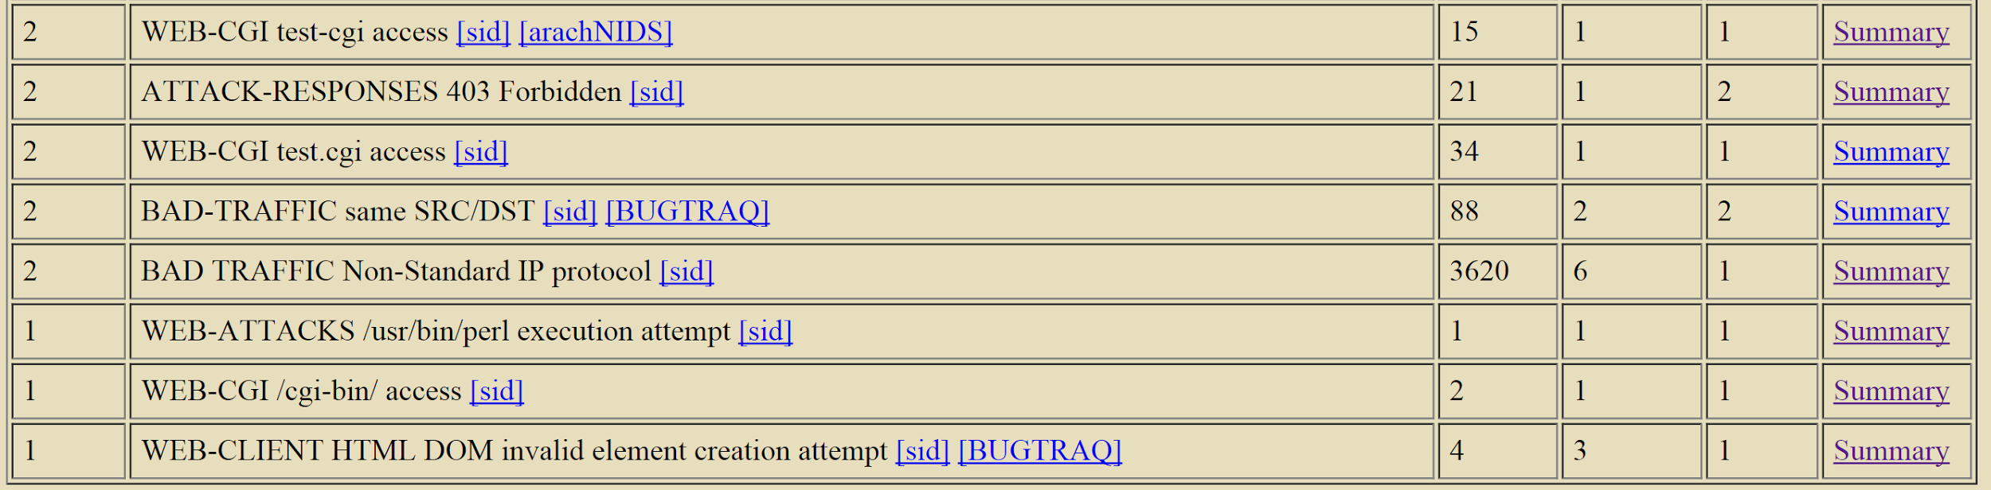

## Remote Desktop Exploit on Windows XP

According to Microsoft, there is a vulnerability that allows remote code execution on our Windows XP workstation. Although this is not directly related to Remote Desktop Protocol that is implemented on our machine, it is still an exploit that uses our Windows workstation. The following screenshot depicts more detail regarding our exploit:

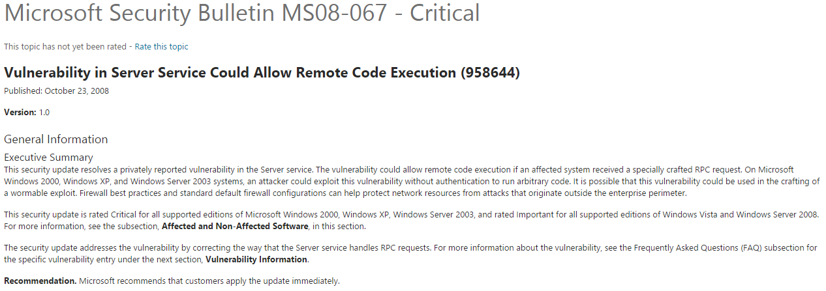

In further detail, this exploit affects the following machines:

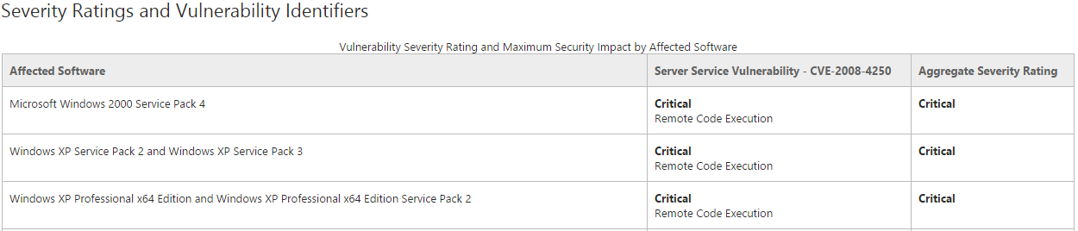

We have intentionally disregarded patching our machine for the sake of allowing remote exploitation. Also, because our version of Windows XP is “Black Edition” -- meaning, a customized operating system -- we are positive that the operating system has more than just the aforementioned vulnerability. Unfortunately, throughout our designing and testing of our network, we were unable to conduct the following attack in order to compromise our network.

For more information about this vulnerability, please visit the following link at Microsoft:

*https://technet.microsoft.com/en-us/library/security/ms08-067.aspx*

# 

# 

# Design Work Conclusion

Our project team feels that our network is secure enough to not crumble at the first stage of being hacked. At the same time, our team feels that our network is vulnerable enough to be enticing for hungry attackers to visit our website. Most importantly, we believe that our method of provoking attackers using religious terrorism and racism will ultimately allow us to gather richer evidence of attacks.

Our system is allowing a Denial of Service attack. In the case where the attack occurs first before any of the other attacks were performed, we will reconfigure our network to disallow the attack but continue to allow other attacks. In our deliverables, we will submit two or more components if the network has not sufficiently gathered enough evidence of our intended exploits.

We are expected to launch our network on Thursday, October 30 2014. We will allow the network to live for roughly four weeks or until the system has been severely compromised, whichever comes first. However, we know that we will not have a problem attracting attackers since we have already experienced it first hand in our preliminary launch and testing phases. See **Preliminary Lessons Learned** for more details.

Our final report documentation, with all relevant log files and such, will be submitted on Thursday, December 11 2014. Included with the final report will be a brief but concise presentation regarding our findings and learning outcomes from our project. The presentation will also occur on Thursday, December 11 2014.

# Preliminary Lessons Learned

During the setup phase of our honeypot we did not have remote logging setup. In this time our network was compromised multiple times, in each instance the attacker was able to gain access to our firewall and and delete all of the logs and snort alerts on our firewall. This experience solidified in our minds the importance of remote logging. For something that is so easy to setup it is easily one of the most important security features you can add to your network. Without the evidence provided by the logs and alert you can learn from the attack and harden your system to future attackers.

# 

# Appendices

## Appendix I - Files on Disk

Files located on-disk are the following:

* COMP 8506 - Major Project Design Work (.pdf)
* c8506_wExp.zip (Our Website Application using CodeIgniter Framework)
* c8506_final.sql (Our SQL Database Export containing:)
  + books table (to dynamically load our books in web app)
  + members table (to store membership data)
  + creditcard table (to entice attackers for SQL injection)
* Log Files (directory)
  + DoS-capture.pcapng.gz
  + sshd_brute_logs.txt
* Firewall Scripts (directory)
  + close.sh
  + init-network.sh
  + open.sh
  + quick.sh
  + reset.sh
* Tools (directory)
  + daq-2.0.4.F20.x86_64.rpm
  + snort-2.9.7.0-1.f20.x86.64.rpm
  + snort-rules.zip
  + SnortSnarf-1.0.tar.gz
  + mimikatz_trunk.zip
    - Win32 (directory)
      * mimikatz.exe
      * mimilib.dll
      * mimidrv.sys
    - x64 (directory)
      * mimikatz.exe
      * mimilib.dll
      * mimidrv.sys